East Forsyth High School
Class of 2025 Senior Letters
The Orange Envelope

What is a senior letter?
Senior letters are positive letters written to senior students. They are delivered to students during mandatory Graduation Practice at the end of the school year in an orange envelope. More details about Graduation Practice will be shared later.
What can be written in a senior letter?
There are many acceptable topics for a senior letter. These include but are not limited to:
- Congratulating the senior on graduating
- Wishing the senior well in their next phase of life (college, military, career, etc.)
- Reminiscing on fond memories (childhood, school, social gatherings, etc.…)
- Please note - This is NOT an opportunity to bring up old grudges or to get one last dig at a person.
When do seniors receive their letters?
Seniors will receive their senior letters at the mandatory graduation practice at the end of the school year. Seniors will not be able pick up letters early because time is needed to sort and stuff the envelopes.
How do I get a senior letter to a student?
Please place all senior letters in envelopes. On the outside of the envelope (in the middle), please put the student’s full LEGAL name. It is not necessary to add the mailing address if you are dropping the letter off at the school. If you are unable to drop the letters off at East Forsyth High School, please mail the senior letter to the following address:
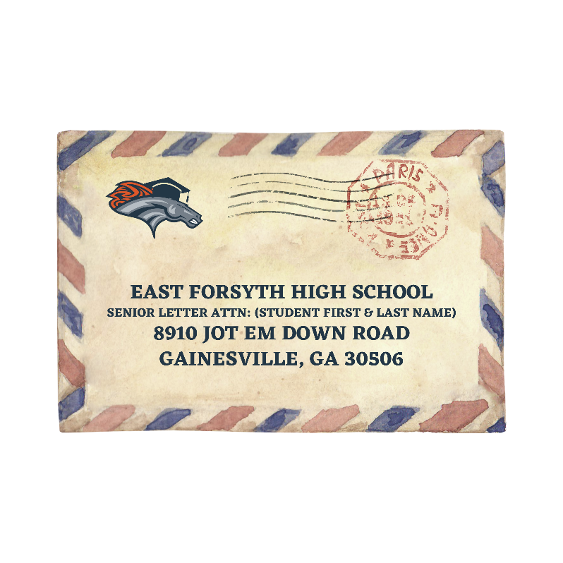

What if somebody outside of school wants to send a letter?
- People who live locally can mail their letters or choose to bring their letters to the school and drop them off in the front office in the box labeled Orange Envelope Drop Off.
- People who live farther away can mail their letters, or, if saving on postage is a real concern, they can e-mail the letters to a student’s parent/guardian to print off and drop off at the school. School staff will not print off emailed letters.
- Students can drop off letters in the front office.
Who reads the senior letters?
Senior letters are delivered directly to the senior students during mandatory graduation practice. We will not be able to review every letter; however, all letters are subject to be opened by senior staff sponsors.
Can people send items other than letters?
This is NOT permitted. If people want to send money, please send that directly to the student’s home address. We make every effort to deliver letters to the correct senior, but we do not want to be responsible for checks, cash, and gift cards.
We are only equipped to store and sort letters. If people want to send a senior a large gift or photo album of memories, please have those delivered directly to the senior at their home address.
When can I begin turning in senior letters?
We will receive letters beginning February 3rd until Friday, April 25th in the front office. Friday, April 25th is a hard deadline as we need ample time to sort and organize the letters.
How can I ensure that my student receives letters?
We suggest that parents/guardians reach out to community members, friends, and family that have been an integral part of their child’s life to participate in writing a senior letter. Feel free to share the information in this mailer with them so they understand the guidelines and deadlines.

We are so excited to continue the Orange Envelope tradition to celebrate the Class of 2025!

Please contact Mrs. Rinehart with any questions regarding senior letters.
arinehart@forsyth.k12.ga.us
770-888-1235 ext. 461041

